1. I, the Provider, do hereby provide and give my voluntary prior free and unconditional permission and/ or consent to <<insert vendor name>>, having its registered office situated at <<insert vendor registered office address>> (“Company”) to collect, store, process and/ or transfer my Information pertaining to my **Personally identifiable information** (PII) (including copy of the PAN card) (the “PAN”) for the purposes as listed below in section 2.
2. I fully understand and agree that my PII is collected by the Company for initiating and processing my job candidature as prospective candidate for employment opportunity with exl Service.com (India) Private Limited and /or its Indian affiliates (collectively referred to as “**EXL**”). I agree that Company would be sharing my PAN with EXL for the purposes of screening, shortlisting, and processing of a job / employment opportunity with EXL (“**Purpose**”).
3. I have provided the PII on clear understanding and knowledge that such Information can be disclosed, transferred, collected, stored, processed or shared by the Company and/or obtained by EXL for the aforesaid Purpose and shall be used for legitimate or lawful purposes of ensuring my identification only, and shall be retained by the Company and/or obtained by EXL only till the time same is required to be retained for afore-said Purpose or for compliance with any law for the time being in force.
4. I declare that I have not impersonated any other person whosoever or wheresoever while providing the Information pertaining to PAN, and I have nothing to correct in, or amend, the PAN. In case if any Information pertaining to my PAN needs to be corrected, modified, completed, updated or amended, or erased, or to raise a request to delete the PII, I can write to the Company at Privacy@exlservice.com as applicable for such correction and modification or erasure. I agree to furnish only such information as can verifiably be authenticated, while exercising my right of correction or erasure of the Information.
5. I, the above-named Provider, do hereby accept and agree that I am aware of the Company’s and EXL’s privacy and grievance redressal policies, which are available for my view at the respective websites of the Company and EXL at https://www.exlservice.com/privacy-policy and ________ respectively, and I have read / I am obligated to read the aforesaid policies. I agree not to register a false or frivolous grievance or complaint.
6. I, understand PAN is shared by the Company or is being requested by EXL for a lawful purpose and to verify my identification and such sharing or obtaining of Information pertaining to the PAN is necessary for the afore said Purpose, and I have complete knowledge, including the Purpose, of Information pertaining to the PAN being shared or obtained.
7. I understand and agree that the PAN shall be retained by the Company and/or EXL as per their respective retention policies which are available for my review at the website - exlcareers.peoplestrong.com respectively, and I have read / I am obligated to read the afore said policies.
8. I further agree that the Company and/or EXL shall not be responsible for the authenticity of the Information pertaining to the PAN and I shall not hold the Company and/or EXL liable, accountable and / or responsible for my any acts and/ or omissions.
9. I declare that I have not suppressed any material information while providing Information pertaining to my PII.
10. I, the above-named Provider agree, consent and accept that I have signed this prior permission / consent letter voluntarily of my own free will & consent and after forming a rational judgment, which in my considered opinion is in my interest.

Signed by the above-named Provider with his / her free consent after reading and fully understanding the above said and after forming a rational judgment.

**Signature of the Provider:**

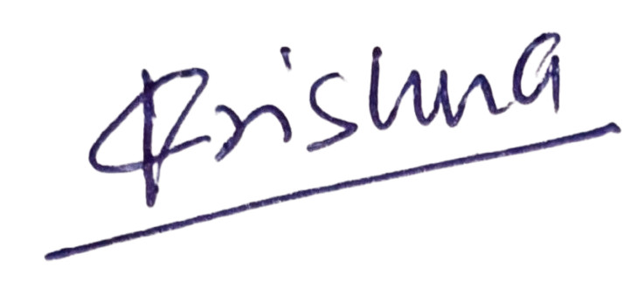

**Name of the Provider: Krishna Kumar Verma**

**Place: Noida Sector 15 uttar pradesh**

**Date: 18/09/2024**

**Personal Email of the Provider: krishnakrverma97@gmail.com**

**Mobile Number of the Provider: 7905968734**